Rizal Technological University

College of Engineering, Architecture and Technology

**Activity 2**Stack Implementation of Linklist in C++

Subject **:** Data Stucture And Algorithm

Name **:** Art Lisboa

Instructor **: Engr. Ezekiel Nequit**

Date Submitted **: October 17 2020**

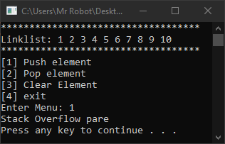 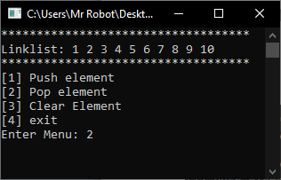

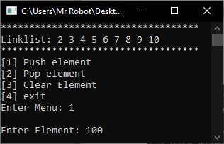

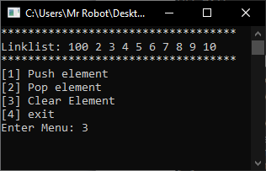

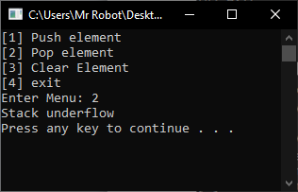

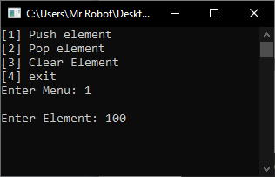

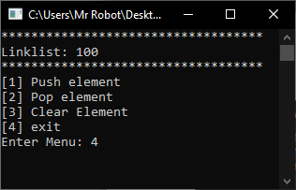

**Source code:**

#include <iostream>

#include<String>

using namespace std;

///CLASS LINKLIST

class linklist{

public:

struct Node {

int data;

struct Node *next;

};

struct Node* head = NULL; //node

void push(int new_data) {

Node* new_node = new Node;

new_node->data = new_data;

new_node->next = NULL;

new_node->next = head;

head = new_node;

return;

}

void display() {

struct Node* ptr;

ptr = head;

while (ptr != NULL) {

cout << ptr->data << " ";

ptr = ptr->next;

}

}

void pop()

{

struct Node* temp1 = head;

head = temp1->next;

delete(temp1);

return;

}

void clear()

{

head = NULL;

return;

}

};

////CLASS TAKBO INHERIT FROM LINKLIST

class takbo :public linklist{

public:

int size = 0;

void insrt_elmnt(){

try{

if (size != 10){

size++;

int frst_elmnt;

cout << "\nEnter Element: ";

cin >> frst_elmnt;

push(frst_elmnt);

run();

}

else{

cout << "Stack Overflow pare" << endl;

system("pause");

run();

}

}

catch (exception e){

cout << "Number Lang kapatid";

system("pause");

return insrt_elmnt();

}

}

void ask() {

for (int i = 0; i < 35; i++)

{

cout << "*";

}

cout << endl;

}

void display_linklist(){

if (size != 0){

ask();

cout << "Linklist: ";

display();

cout << endl;

ask();

}

}

void run()

{

string chces;

system("cls");

display_linklist();

cout << "[1] Push element\n";

cout << "[2] Pop element\n";

cout << "[3] Clear Element\n";

cout << "[4] exit\n";

cout << "Enter Menu: ";

cin >> chces;

if (chces == "1")

{

insrt_elmnt();

}

else if (chces == "2"){

if (size != 0)

{

size--;

pop();

}

else{

cout << "Stack underflow" << endl;

system("pause");

}

return run();

}

else if (chces == "3")

{

size = 0;

clear();

return run();

}

else if (chces == "4")

{

system("exit");

}

else{

cout << "Wrong Input!" << endl;

system("pause");

system("cls");

return run();

}

}

void input(){

push(10);

push(9);

push(8);

push(7);

push(6);

push(5);

push(4);

push(3);

push(2);

push(1);

size = 10;

}

};

///main function

int main() {

takbo tak;

tak.input();

tak.run();

}